Dashboard Design
Team ID | Individual
Project Title | Smartphone Usage, Digital Addiction & Well-Being Analytics
Maximum Marks | 5 Marks

Creating an effective analytical tool for behavioral well-being involves thoughtful design to ensure that complex metrics (like screen time versus stress or addiction level) are clear, relevant, and actionable for investigators or individuals.
Activity 1: Interactive and Visually Appealing Dashboards
To deliver maximum diagnostic and user value, take care of the following technical and design implementations:
• Clear and Intuitive Layout: Group the dashboard into a left-hand filter panel (Slicers) and a main content area separated into high-level summary KPIs (Top) and deep-dive analytical charts (Bottom).
• Use Appropriate Visualizations: Switch between distribution views (pie/donut charts) for categorical variables and behavior-tracking plots (bar/line charts) for numerical continuous data.
• Colour and Theming: Utilize a high-contrast dark theme (similar to the black backdrop template) using color syntax (e.g., deep purples, blues, and striking warning pinks) to categorize behavioral severity levels dynamically.
• Interactive Filters and Slicers: Allow immediate cross-filtering by demographic metadata such as Gender, Age Brackets, and Stress Levels.
• Drill-Down Capabilities: Provide capabilities to view a generalized risk bracket and then drill straight down to individual baseline metrics (e.g., App Opens vs. Notifications per Day).

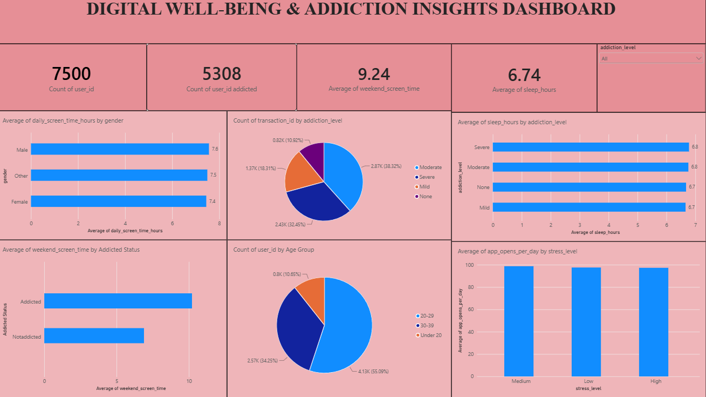
Here are five potential outcomes derived from the processed screen time behavioural dataset logs:
1. Average Smartphone Screen Time: The tracked user cohort demonstrates an average continuous interaction landscape of 6.43 Hours daily across subsets, highlighting baseline system engagement limits.
2. Notification Volumetric Loading: Telemetry logs document a high-density environment tracking a mean threshold of 146 notifications per day per standard observation unit.
3. System Accessibility Demands: Core hardware interaction monitoring reveals users trigger an average of 123 device app opens per day, indicating strong checking behaviors.
4. Addiction Proximity Demographics: Strategic multi-axis profiling filters continuous parameters to isolate high-risk targets matching severe diagnostic classification criteria within the 5 unique active sessions.
5. Behavioral Rest Disruptions: Cross-column tracking exposes explicit physical patterns where severe dependency label categories show direct alignment with compressed sleep duration timelines.
Weekend Surge Dynamics: Average screen utilization scales significantly upwards during weekend cycles, often inflating continuous usage metrics to values exceeding 11 to 14 total hours per day.
•Academic & Professional Disruption: A major proportion of subjects categorized with High Stress Levels simultaneously self-report a definitive "Yes" flag for negative impacts on their academic or professional workflows.

